Introduction
The Iterator Design Pattern is a behavioral design pattern that provides a way to access elements of an aggregate object sequentially without exposing its underlying representation. If you come from C++, Java, or any language where iterators are used, and have done even a little bit of DSA, you must have used iterators. Until today, you may not have even known it's a design pattern.
This is also a very interesting design problem because in many LLD interviews, they ask: "Design your own iterator."

Why Do We Need Iterators? (The Problem)

The Normal Approach to Traversal
Every data structure has its own way of traversal:
Linked List Traversal:
text
temp = head;
while (temp != null) {
// process temp
temp = temp->next;
}
Binary Tree Traversal:
- Level Order Traversal
- Inorder Traversal
- Postorder Traversal
- Preorder Traversal
Vector/Array Traversal:
- Simple for loop with indexing
Playlist (List of Songs):
- Depends on how songs are stored (vector, linked list, map, etc.)

The Core Problem
Consider a Playlist class that stores songs in a vector:
cpp
class Playlist {
vector<Song> songs;

public:
void playEntirePlaylist() {
for (int i = 0; i < songs.size(); i++) {
// play songs[i]
}
}
};
What if we change the underlying data structure to a linked list?
Now playEntirePlaylist() breaks because:
- You can't use indexing in a linked list
- You must use a temporary pointer with while (temp != null)
- Every method that traverses songs needs to be changed

The Single Responsibility Principle Violation
This violates the Single Responsibility Principle (SRP):
- Business Logic: A playlist should know how to add songs, remove songs, get song by name/ID, etc.
- Storage/Traversal Logic: How the songs are stored and traversed should be separate
When you keep both storing logic and traversing logic in the same class:
- Every class breaks SRP
- Changing data structure requires changing all traversal-related methods
- Code becomes tightly coupled and hard to maintain

The Solution: Separate the Traversal Logic
The playlist should NOT know:
- How to iterate through the list of songs
- Whether it's stored in vector, linked list, tree, or map
- How to take a temporary pointer and loop until null
The playlist should only know:
- "I have an iterator"
- "I call hasNext() to check if next song exists"
- "I call next() to get the next song"
Benefits:
- If the underlying data structure changes (e.g., vector → linked list), only the iterator needs to change
- The Playlist class and its methods (getSongByName, getSongByID, addSong, removeSong) remain unchanged
- They simply call hasNext() and next() on the iterator
- The iterator handles all the internal complexity

Real-World Example: Music Player Application

Classes Involved
- Song: Represents a song
  - String name (title)
  - String path (file path)
- Playlist: Manages a list of songs
  - Has one-to-many relationship with songs
  - CRUD operations: add song, remove song
  - playEntirePlaylist(): Needs to iterate through songs
  - getSongByName(): Needs to iterate to find a song
- Linked List: A custom linked list data structure
  - int data
  - LinkedList* next
- Binary Tree: A custom binary tree data structure
  - int data
  - BinaryTree* left
  - BinaryTree* right

Why Playlist Needs Iteration
- playEntirePlaylist(): Must loop through all songs
- getSongByName(): Must loop through songs to find a match
- getSongByID(): Must loop through songs to find a match
All these methods need traversal, but the playlist shouldn't know HOW to traverse.

Iterator Pattern Design

Two Hierarchies
The Iterator pattern creates two parallel hierarchies:
1. Iterator Hierarchy:
- Iterator (abstract/interface) → hasNext(), next()
- Concrete Iterators: LinkedListIterator, BinaryTreeIterator, PlaylistIterator
2. Iterable Hierarchy:
- Iterable (abstract/interface) → getIterator()
- Concrete Iterables: LinkedList, BinaryTree, Playlist

Relationship
- Iterable has-a Iterator (has-a relationship)
- LinkedList is-a Iterable (is-a relationship, inheritance)
- BinaryTree is-a Iterable
- Playlist is-a Iterable

Why Separate Iterable Interface?
Instead of adding getIterator() to each class individually, we create an Iterable interface:
- Any class that inherits Iterable can be iterated
- Ensures a common contract across all iterable classes
- Promotes polymorphism

UML Design
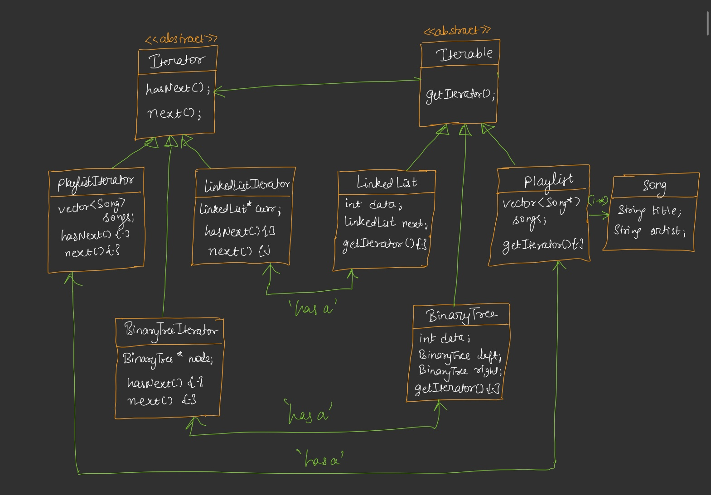

Core Interfaces
Iterator (Abstract/Interface):
text
<<interface>> Iterator<T>
+ hasNext() : bool
+ next() : T
Iterable (Abstract/Interface):
text
<<interface>> Iterable<T>
+ getIterator() : Iterator<T>

Concrete Classes
text
LinkedList implements Iterable<LinkedList>
- data : int
- next : LinkedList*
- getIterator() : LinkedListIterator

LinkedListIterator implements Iterator<int>
- current : LinkedList*
- hasNext() : bool
- next() : int

BinaryTree implements Iterable<BinaryTree>
- data : int
- left : BinaryTree*
- right : BinaryTree*
- getIterator() : BinaryTreeIterator

BinaryTreeIterator implements Iterator<BinaryTree>
- current : BinaryTree*
- stack : Stack<BinaryTree*>
- hasNext() : bool
- next() : BinaryTree*

Playlist implements Iterable<Playlist>
- songs : List<Song> (one-to-many)
- getIterator() : PlaylistIterator

PlaylistIterator implements Iterator<Song>
- songs : List<Song>
- index : int
- hasNext() : bool
- next() : Song

Song
- title : String
- artist : String

Client Flow
text
Client → calls getSongByName() on Playlist
Playlist → calls getIterator() → gets PlaylistIterator
Playlist → loops: while (it.hasNext()) { it.next() }

Code Implementation Details

Templates/Generics
Why use templates (C++) or generics (Java)?
- hasNext() always returns bool — doesn't depend on type
- next() returns different types depending on the iterator:
  - LinkedListIterator.next() → returns int (or LinkedList reference)
  - BinaryTreeIterator.next() → returns BinaryTree reference
  - PlaylistIterator.next() → returns Song
- Therefore, Iterator and Iterable must be templated/generic

LinkedList Iterator
cpp
template <typename T>
class Iterator {
public:
virtual bool hasNext() = 0;
virtual T next() = 0;
};

template <typename T>
class Iterable {
public:
virtual Iterator<T>* getIterator() = 0;
};

class LinkedList : public Iterable<int> {
public:
int data;
LinkedList* next;

LinkedList(int data) {
this->data = data;
this->next = nullptr;
}

Iterator<int>* getIterator() override {
return new LinkedListIterator(this); // passes 'this' reference
}
};

class LinkedListIterator : public Iterator<int> {
private:
LinkedList* current;

public:
LinkedListIterator(LinkedList* head) {
this->current = head;
}

bool hasNext() override {
return current != nullptr;
// OR: return current->next != nullptr;
// Depends on use case
}

int next() override {
int value = current->data;
current = current->next;
return value;
}
};
How hasNext/next work for LinkedList:
- hasNext(): Check if current != nullptr (or current->next != nullptr)
- next(): Store current->data in a value, move current = current->next, return value
Important note on hasNext:
- If you check current->next != nullptr, then at the last node (3 in 1→2→3), hasNext() returns false, so you can't move forward from 3
- But you've already processed 3 when you called next() on 2
- Alternatively, check current != nullptr — then at node 3, hasNext() returns true, you call next(), get value 3, and current becomes null
- Choose based on your use case

Binary Tree Iterator (Inorder)
cpp
class BinaryTree : public Iterable<BinaryTree> {
public:
int data;
BinaryTree* left;
BinaryTree* right;

BinaryTree(int data) {
this->data = data;
this->left = nullptr;
this->right = nullptr;
}

Iterator<BinaryTree>* getIterator() override {
return new BinaryTreeInorderIterator(this); // passes root reference
}
};

class BinaryTreeInorderIterator : public Iterator<BinaryTree> {
private:
stack<BinaryTree*> st;
BinaryTree* current;

void pushLeft(BinaryTree* node) {
while (node != nullptr) {
st.push(node);
node = node->left;
}
}

public:
BinaryTreeInorderIterator(BinaryTree* root) {
current = root;
pushLeft(current);
}

bool hasNext() override {
return !st.empty();
}

BinaryTree* next() override {
BinaryTree* node = st.top();
st.pop();
pushLeft(node->right);
return node;
}
};
Why iterative (stack-based) approach?
- We only have hasNext() and next() — we can't iterate the whole tree at once
- We need controlled, one-by-one traversal
- Recursive approach iterates the entire tree at once — not suitable for iterator pattern
- Stack-based iterative inorder traversal allows step-by-step traversal
Inorder traversal algorithm:
- Push all left descendants onto stack
- Pop top node → this is the next element
- Push all left descendants of the popped node's right child
- Repeat
Customization:
- You can create PreorderIterator, PostorderIterator, LevelOrderIterator — any order you want

Playlist Iterator
cpp
class Song {
public:
string title;
string artist;

Song(string title, string artist) {
this->title = title;
this->artist = artist;
}
};

class Playlist : public Iterable<Song> {
private:
vector<Song> songs;

public:
void addSong(Song song) {
songs.push_back(song);
}

Iterator<Song>* getIterator() override {
return new PlaylistIterator(songs);
}
};

class PlaylistIterator : public Iterator<Song> {
private:
vector<Song> songs;
int index;

public:
PlaylistIterator(vector<Song> songs) {
this->songs = songs;
this->index = 0;
}

bool hasNext() override {
return index < songs.size();
}

Song next() override {
return songs[index++]; // return then increment
// OR: Song val = songs[index]; index++; return val;
}
};

Client Code (Main)
cpp
int main() {
// LinkedList: 1 → 2 → 3
LinkedList* head = new LinkedList(1);
head->next = new LinkedList(2);
head->next->next = new LinkedList(3);

Iterator<int>* it1 = head->getIterator();
while (it1->hasNext()) {
cout << it1->next() << " ";
}
// Output: 1 2 3

// Binary Tree: 2
// / \
// 1 3
BinaryTree* root = new BinaryTree(2);
root->left = new BinaryTree(1);
root->right = new BinaryTree(3);

Iterator<BinaryTree>* it2 = root->getIterator();
while (it2->hasNext()) {
cout << it2->next()->data << " ";
}
// Output: 1 2 3 (inorder)

// Playlist
Playlist playlist;
playlist.addSong(Song("Admiring You", "Karan Aujla"));
playlist.addSong(Song("Hustle", "Anuj Jain"));

Iterator<Song>* it3 = playlist.getIterator();
while (it3->hasNext()) {
Song song = it3->next();
cout << song.title << " by " << song.artist << endl;
}

return 0;
}
Key observation: The client code for all three data structures is identical:
cpp
while (it->hasNext()) {
auto val = it->next();
// process val
}
This is the power of the Iterator pattern — uniform traversal interface regardless of underlying data structure.
Code – See Notes….

Standard UML Diagram

Structure

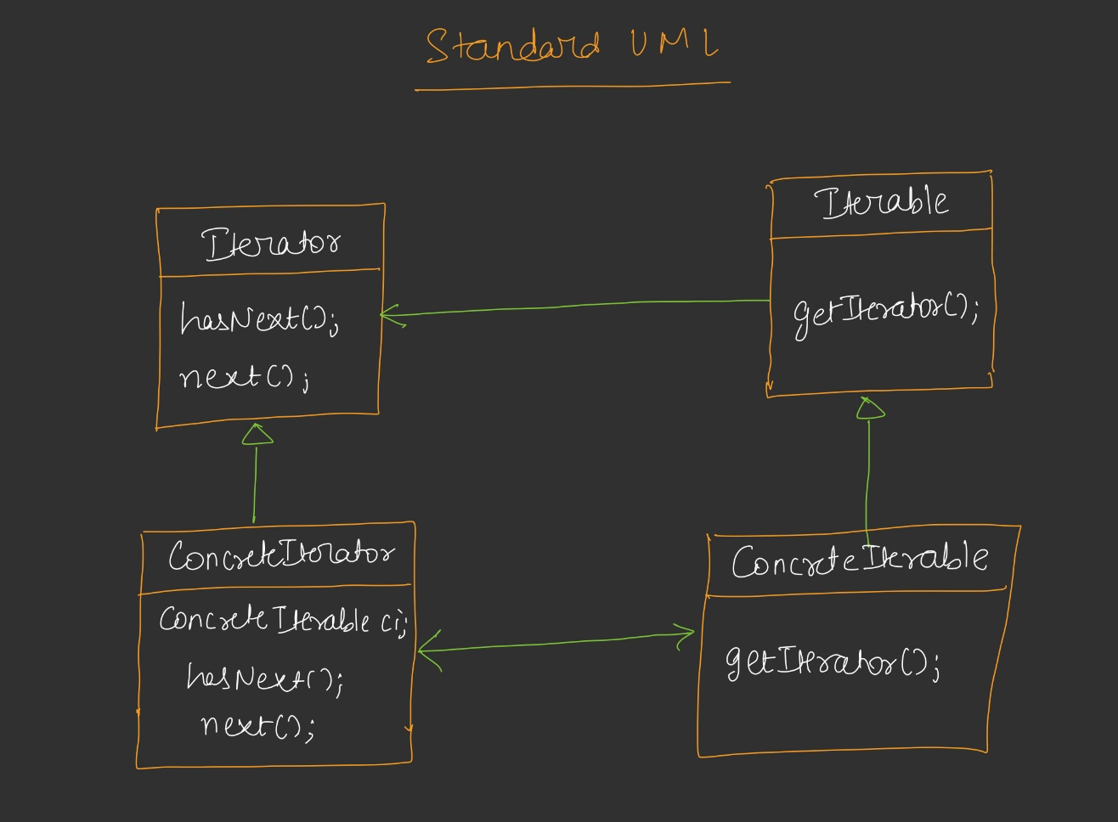

Relationships
- Iterable ←(implements)— ConcreteIterable (is-a)
- Iterator ←(implements)— ConcreteIterator (is-a)
- ConcreteIterable →(has-a)— ConcreteIterator (getIterator returns it)
- ConcreteIterator →(has-a)— ConcreteIterable (needs reference to iterate over)
Important: Arrows go both ways because:
- The iterable needs an iterator reference (to return from getIterator)
- The iterator needs an iterable reference (to know what it's iterating over)

Client Interaction
text
Client → ConcreteIterable.getIterator() → returns ConcreteIterator
Client → ConcreteIterator.hasNext() / next() → sequential access

Standard Definition
"The Iterator Pattern provides a way to access the elements of an aggregate object sequentially without exposing its underlying representation."

Breakdown of Definition
- Aggregate object: Any object that contains many values or references to itself
  - Linked list (stores references to itself)
  - Binary tree (stores references to itself)
  - Playlist (contains a list of songs)
- Sequentially: One element at a time, in order
- Without exposing underlying representation:
  - Client doesn't know if it's a vector, linked list, tree, or map
  - Client doesn't know how hasNext() checks for next element
  - Client doesn't know how next() fetches the next element
  - Client only knows: call hasNext(), call next()

Benefits of Iterator Pattern
- Single Responsibility Principle: Separates storage/traversal logic from business logic
- Uniform Interface: Same hasNext()/next() for all data structures
- Encapsulation: Hides internal representation of the aggregate object
- Flexibility: Change underlying data structure without affecting client code
- Multiple Traversals: Can create different iterators (inorder, preorder, postorder) for the same data structure
- Lazy Evaluation: Elements fetched one at a time (unlike recursive traversal which processes all at once)

Trade-offs
Verbosity: Using iterators requires more code:
- Get iterator using getIterator()
- Loop with hasNext()
- Call next()
Compared to a simple for loop. But the benefits (SRP, encapsulation, flexibility) outweigh this verbosity.

Homework Assignment
Add two more methods to the Iterator pattern:
- previous(): Returns the previous element
- hasPrevious(): Checks if a previous element exists
Purpose: To iterate any data structure in reverse order.

Implementation Steps
- Add previous() and hasPrevious() to the Iterator interface
- Override them in all concrete iterators:
  - LinkedListIterator: Need to track previous node (may need doubly linked list or maintain a stack/history)
  - BinaryTreeIterator: Need reverse inorder traversal logic
  - PlaylistIterator: Simple — just decrement index
- In your iterables, you can either:
  - Keep one getIterator() method that supports both forward and backward
  - Have two methods: getSequentialIterator() and getReverseIterator()
Design choice is yours — both approaches are valid.

Example for PlaylistIterator
cpp
class PlaylistIterator : public Iterator<Song> {
private:
vector<Song> songs;
int index;

public:
PlaylistIterator(vector<Song> songs) {
this->songs = songs;
this->index = -1; // start before first element
}

bool hasNext() override {
return index + 1 < songs.size();
}

Song next() override {
return songs[++index];
}

bool hasPrevious() override {
return index - 1 >= 0;
}

Song previous() override {
return songs[--index];
}
};

Real-World Use Cases
- All Programming Languages with Iterators: C++ STL iterators, Java Iterator interface, Python iterators — all use this design pattern
- Java Collections Framework:
  - ArrayList, LinkedList, HashSet, TreeSet — all implement Iterable
  - Each has its own Iterator implementation
- C++ STL:
  - vector<int>::iterator, list<int>::iterator, map<K,V>::iterator
  - All follow the Iterator pattern
- Database Cursors:
  - Iterate through result sets one row at a time
  - hasNext() / next() equivalent: fetchone(), fetchmany()
- File System Traversal:
  - Iterating through files in a directory
  - Tree traversal of folder structures
- Music Player Applications:
  - Playlist iteration (our example)
  - Next/previous song functionality
- Social Media Feeds:
  - Infinite scroll — loads next batch of posts
  - hasNext() checks if more posts exist

Key Takeaways
- Problem: Traversal logic mixed with business logic violates Single Responsibility Principle
- Solution: Extract traversal into separate Iterator classes
- Two hierarchies: Iterable (can be iterated) and Iterator (does the iterating)
- Core methods: hasNext() and next()
- Templates/Generics: Required because next() return type varies
- Uniform interface: Same loop pattern for linked list, tree, playlist, vector — any data structure
- Encapsulation: Underlying representation is hidden from client
- Flexibility: Change data structure by changing only the iterator
- Iterator is a design pattern: What you've been using in DSA is actually a formal design pattern
- Interview favorite: "Design your own iterator" is a common LLD interview question

Summary Table
Aspect | Details
Type | Behavioral Design Pattern
Purpose | Sequential access to aggregate objects without exposing representation
Core Interfaces | Iterator (hasNext, next), Iterable (getIterator)
Key Principle | Single Responsibility Principle
Main Benefit | Uniform traversal + encapsulated representation
Common Implementations | LinkedListIterator, BinaryTreeIterator, PlaylistIterator
Used In | C++ STL, Java Collections, Database cursors, File systems
Interview Question | "Design your own iterator"
Homework | Add previous() and hasPrevious() for reverse iteration

